GUIDE TO THE RIGHT RING SIZE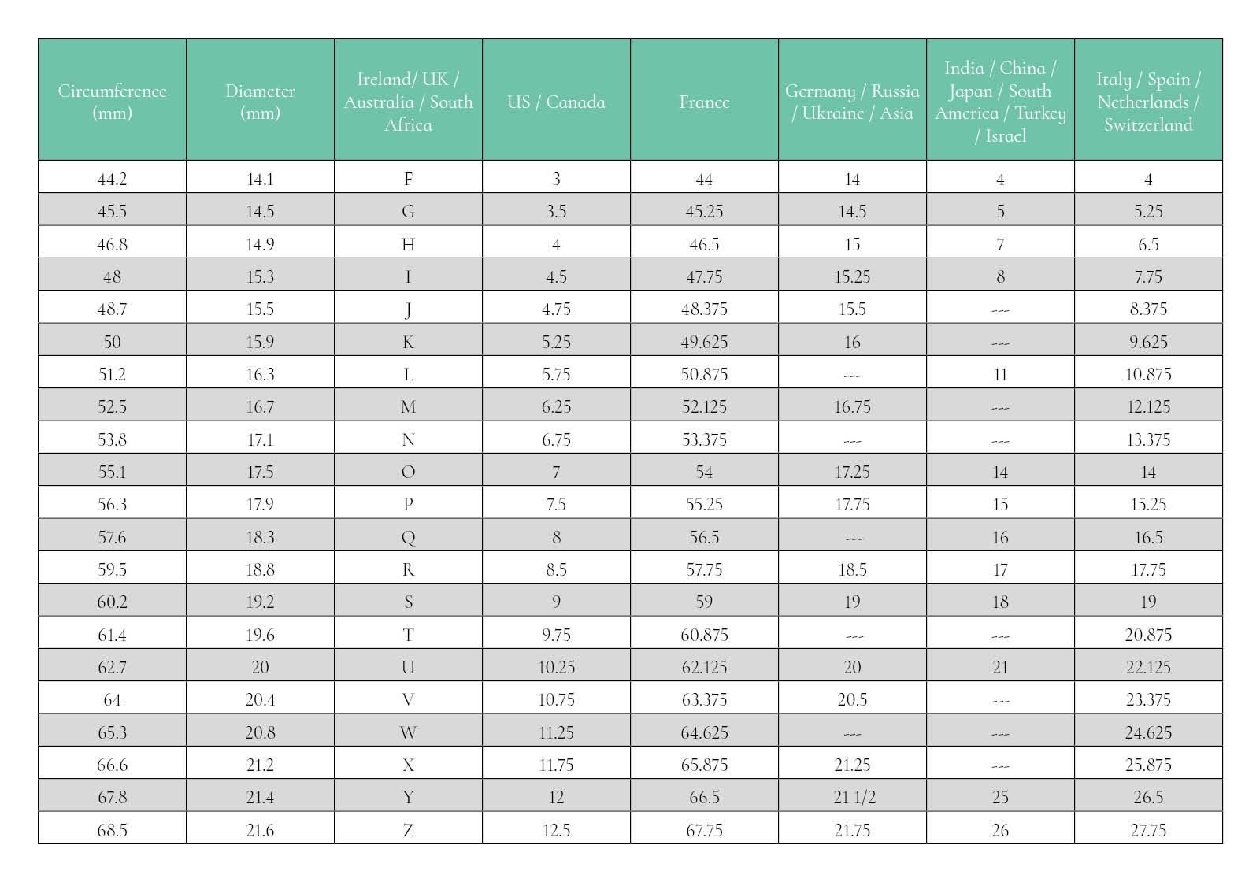
The thicker the ring, the tighter the fit. If your ring of choice has a thick band you may need to go up a size up.
Your fingers are the largest in the evening, therefore this makes for the best time of day to measure your finger size. Avoid measuring when you’re cold, as fingers tend to be at least half a size smaller.
We would always recommend measuring your ring finger before you purchase your rings, however we do recognise this is not always an option, especially when you are planning a surprise proposal.

